Smart Mango – A Smart System for Mango Plantation Management

**Smart Watering System**

2023-309

Status Document II

Withanaarachhci S.P. – IT20466008

Supervisor Name: Ms. Hansika Mahaadikara

Co-supervisor Name: Ms. Shashika Lokuliyana

B.Sc. (Hons) Degree in Information Technology

Department of Information Technology

Sri Lanka Institute of Information Technology Sri Lanka

September 2023

**DECLARATION**

We declare that this is our own work, and this proposal does not incorporate without acknowledgment any material previously submitted for a degree or diploma in any other university or Institute of higher learning and to the best of our knowledge and belief it does not contain any material previously published or written by another person except where the acknowledgment is made in the text.

|  |  |  |
| --- | --- | --- |
| Name | Student ID | Signature |
| Withanaarachchi S.P. | IT20466008 |  |

**Table of Contents**

**DECLARATION** ii

1. Work Breakdown Structure 1

2. Gantt Chart 2

3. Microsoft Teams Details 3

4. Email Details 4

5. WhatsApp Chat Details 5

6. GitLab 6

**Table of Figures**

Figure 1.1 : Work Breakdown Structure 1

Figure 2.1 : Gantt Chart 2

Figure 3.1 : Microsoft Teams Details 3

Figure 4.1 : Email Details 4

Figure 5.1 : WhatsApp Chat Details 5

Figure 6.1 : Git Lab 6

# Work Breakdown Structure

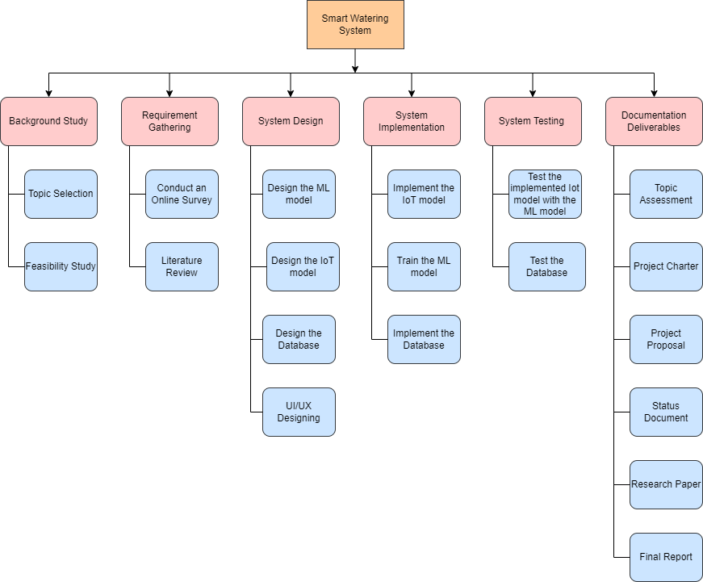

Figure . : Work Breakdown Structure

# Gantt Chart

Figure . : Gantt Chart

# Microsoft Teams Details

Figure . : Microsoft Teams Details

# Email Details

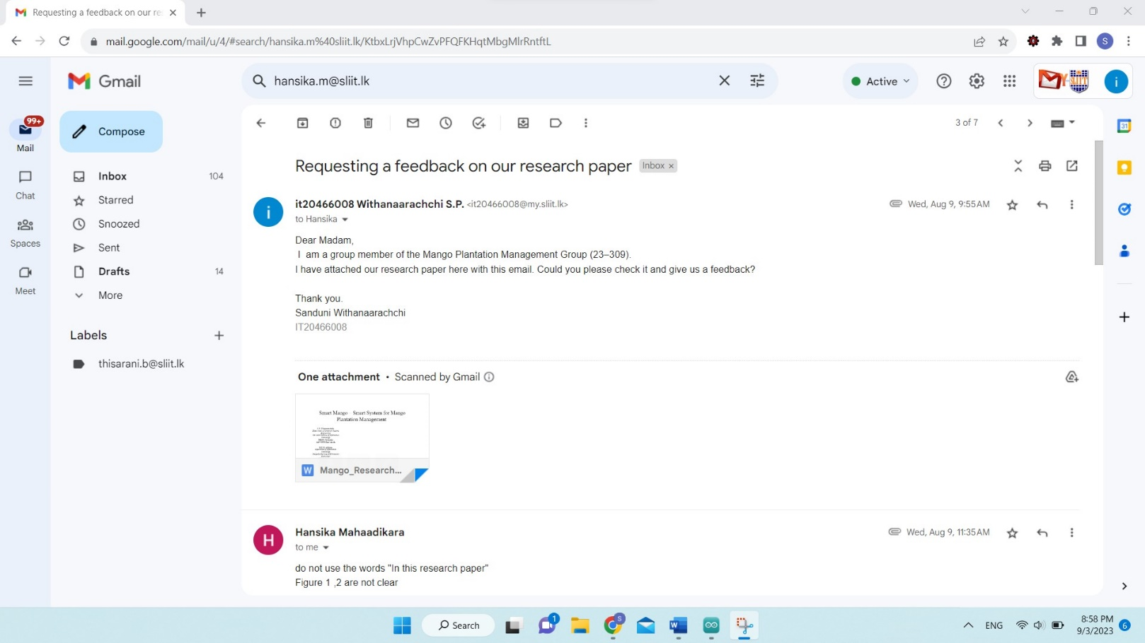

Figure . : Email Details

# WhatsApp Chat Details

Figure . : WhatsApp Chat Details

# GitLab

Figure . : Git Lab